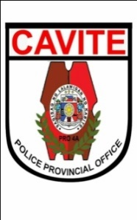Republic of the Philippines

NATIONAL POLICE COMMISSION

**PHILIPPINE NATIONAL POLICE, POLICE REGIONAL OFFICE CALABARZON  
CAVITE POLICE PROVINCIAL OFFICE**

**CARMONA MUNICIPAL POLICE STATION**

J.M. Loyola St., Brgy.Maduya, Carmona, Cavite

**MEMORANDUM**

FOR : Acting Provincial Director

Cavite PPO

(Attn: C, PIDMU)

FROM : Acting Chief of Police

SUBJECT : **Submission of Actual Number of PUPCs and Total Number of**

**Days under PNP Custody**

DATE : February 02, 2022

1. References: Memorandum from C, FD dated January 02, 2022 with

subject same as above.

1. This pertains to the continues programming of the Subsistence Allowance for Persons Under PNP Custody (PUPCs) based on the Actual Number of Days under PNP Custody.
2. In this regard, you are hereby requested to submit the monthly Actual Number of PUPCs and Total Number of Days under PNP Custody for the period covering January 2022 to this office thru email address [caviteppos7@gmail.com](mailto:caviteppos7@gmail.com) NLT today February 02, 8AM using following format

|  |  |  |
| --- | --- | --- |
| **Period Coverd (Monthly)** | **Acutal Number of PUPCs** | **Total Number of Days under PNP Custody** |
| January 2022 | 55 | 1319 |

1. Further, submit the data required for the month of January 2022 on February 2, 2022 and every 2nd of the month.
2. For strict compliance

**JOSEPH C CARLIT**

Police Major